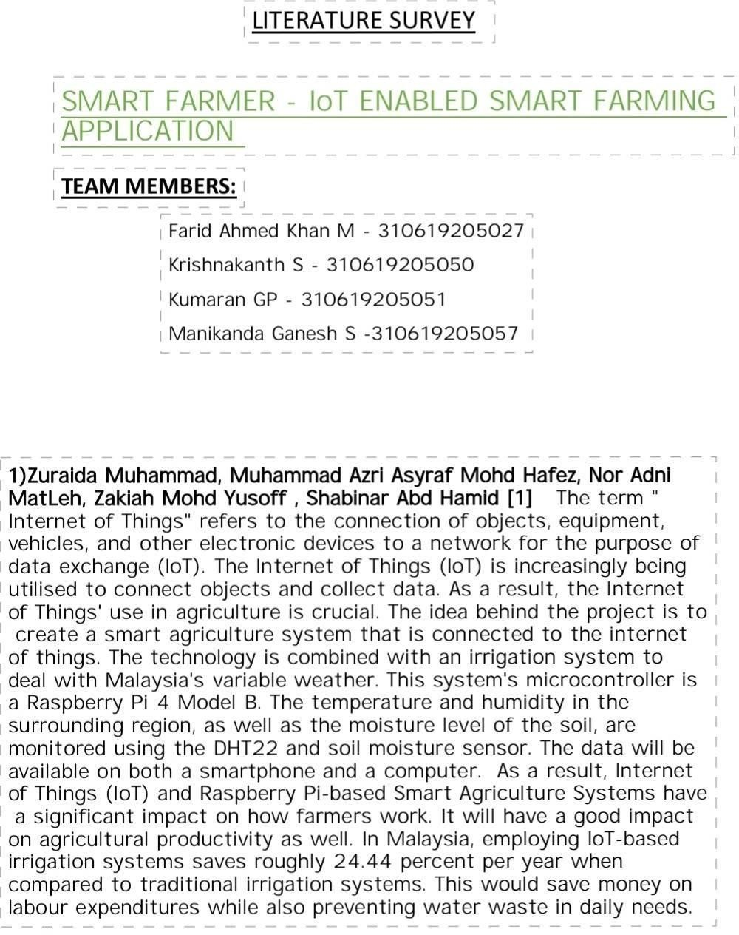

1. Bavadharani K (411819106002)

1. Sathish M (411819106005)
2. Esakkirajan M(411819106305)
3. Arunkumar A(411819106001)

